# SharePoint 2013: Implement NTLM authentication in Windows Phone for SharePoint 2013

Summary: This Windows Phone 8 mobile app demonstrates NTLM support for SharePoint 2013.

The Microsoft SharePoint SDK for Windows Phone 8 introduces support for NTLM.

## Description of the sample

The solution is based on the Windows Phone Empty SharePoint Application template provided by Visual Studio Express 2012. It demonstrates how to create a custom logon page on Windows Phone 8 to authenticate against SharePoint 2013 by using NTLM. A custom logon page enables a user to enter the URL of a SharePoint site and user credentials through the Windows Phone 8 app.

## Prerequisites

This sample requires the following:

* Visual Studio Express 2012
* Microsoft SharePoint SDK for Windows Phone 8

Windows Phone 8 Emulator requires the following:

* Windows 8 Pro
* A processor that supports Second Level Address Translation (SLAT)

alert_note Note

If your computer meets the hardware and operating-system requirements but does not meet the requirements for the Windows Phone 8 Emulator, the Windows Phone SDK 8.0 will install and run. However, the Windows Phone 8 Emulator will not function and you will not be able to deploy or test apps on the Windows Phone 8 Emulator.

## Key components of the sample

The sample contains the following:

* CustomLoginPage.xaml is the custom login page; CustomLoginPage.xaml.cs is the code-behind file.
* Constant.cs contains constants used throughout the sample.

## Configure the sample

To configure the sample, use Visual Studio Express 2012 to open NTLMSampleCode.sln.

## Run and test the sample

To run and test the sample, choose the F5 key. Figure 1 shows the initial screen.

Figure 1. Initial screen of the Windows Phone app

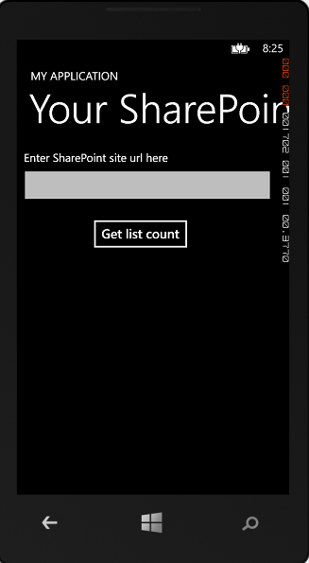

After entering a URL, the user can provide credentials, as shown in Figure 2.

Figure 2. Logon page of the app

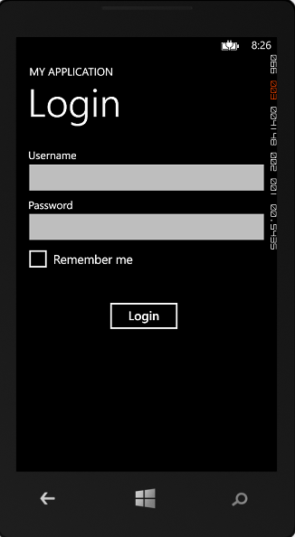

## Change log

| Version | Date |
| --- | --- |
| First version | April 9, 2013 |

## Related content

* [Windows Phone SDK 8.0](http://www.microsoft.com/en-us/download/details.aspx?id=35471)
* [Microsoft SharePoint SDK for Windows Phone 8](http://www.microsoft.com/en-us/download/details.aspx?id=36818)
* [Build mobile apps for SharePoint 2013](http://msdn.microsoft.com/en-us/library/jj163228.aspx)
* [How to: Set up an environment for developing mobile apps for SharePoint](http://msdn.microsoft.com/en-us/library/jj163943.aspx)